ETS Project
Project Description Document

Document Number: PMS-001
This document is intended to collect, in a structured manner, all information involved to the development of the subject project.

Revision History
Revision | Date | Description
A01 | 12/07/2023 | Original Version

Table of Contents
Revision History 1
Introduction 2
High-Level system features overview 3
Conceptual Model Fundamentals 3
System basic workflow 3
Infrastructure 4
PAGEREF _Toc139882169 \h The ETS Local Node components 7
Co-hosting and connectivity notes 7
Background and foreground components 7
General overview 8
Local Node alternative configuration schemes 8
ETSDVM – Device Manger Service 10
Important note on Eye Tracking device availability for ETSDVM 10
Features 10
Health monitoring of ETD 10
ETSUI – User Interface 11
Features 11
The Data Model 11
Users: 12
User Settings: 12
Vocabulary: 12
Documents: 12
Project Development 13
Prerequisites 13
Testing Lab 13
Project Plan 14
Project Phases 15
System Architecture Overview 18
Fundamental Operation Workflows 18
Tobii Pro SDK 22
Epilogue 24
Appendix 25

Introduction

Reading in a non-native language can be challenging for several reasons: Non-native readers may encounter, especially in scientific publications, unfamiliar words, which disrupts the reading flow and makes comprehension difficult. We propose an interconnected system that can provide immediate translation of difficult words, aiming in reducing the disruption to the reading flow. By assisting with challenging words, the software aims to reduce the amount of mental effort that is used from the working memory while performing a cognitive task, such as reading a scientific publication, on the reader side. We aim on making the reading experience more efficient and sustainable, but also with the aid of eye-tracking technology to adapt to the individual reader’s needs, offering a personalized reading aid and extra features concerning the user. By monitoring how users interact with translated text in real time, we can identify areas of confusion or difficulty and use this data for future enhancements. In doing so, our project not only pioneers a new avenue in translation aids but also paves the way for more in-depth studies on language comprehension and learning, contributing to the broader scientific community.

High-Level system features overview
The translation aid system is designed to possess several high-level features:
- Real-time eye tracking: Enabling the system to determine where the user is looking on a screen and use that information to provide context-aware translations.
- Vocabulary Builder: Will add to the user’s users in their language learning journey by constructing a personalized vocabulary and better suggestions.
- Text Customization: Allows users to adjust the visual presentation of the text, enhancing their reading experience.
- Multilingual Support: The system supports multiple languages, making it versatile and adaptable to users' needs.

Conceptual Model Fundamentals
- Users: The system is designed for users who are learning a new language, translating text, or dealing with multilingual documents.
- PC: The system requires a PC with a minimum of 4GB RAM, a 2GHz processor, and an operating system of Windows 10 or later.
- Hardware (eye tracker, mouse, keyboard): The core hardware for this system is an eye-tracking device, which captures and records eye movements. The device will be Tobii Pro Spectrum 300Hz.

System basic workflows
- Insert PDF: Users can insert a PDF file into the system.
- Document Parsing
- Activation of embedded software: trigger the translation.
- Vocabulary builder: the system identifies and creates records for unfamiliar words based on the user's eye movements.
- Text customization: Users can customize the text display by adjusting the font size, style, and zoom level.
- Multilingual support: The system provides support for multiple languages.

Infrastructure
Front-end/UI technologies:
- React
- React-PDF
- Electron
Back-end/API technologies:
- Flask and Flask-CORS
Communication/Request libraries for real-time communication:
- Axios
- Python's Socket library
Tobii Pro API
Translation API: Google Translate API
Data Storage and Management:
- SQLite
- Elasticsearch
Offline functionality:
- Service Workers
Hardware:
- PC and PC specs
- Eye tracker (Tobii Pro Spectrum)
Front-end/UI technologies:
- React: Used as the primary front-end library, React enables the building of the user interface in a modular and maintainable manner. It leverages the virtual DOM for optimized rendering and improved application performance, while JSX contributes to the readability and writability of the code. Then the application needs to be bundled using a tool like Webpack. Once bundled, the application can be served locally using a simple static server.
- React-PDF: This tool is used for rendering PDF documents within the React application. It is particularly useful when there is a requirement to present data in a printable and downloadable format such as reports or invoices.
Back-end/API technologies:
- Flask and Flask-CORS: Acting as the back-end web framework, Flask is a lightweight and flexible tool that offers various utilities and libraries to aid in web application development without imposing unnecessary extras. Flask backend can run locally on the systems machine. When the Flask app starts, it will by default run on localhost, which is accessible only on the same machine. A Flask extension, Flask-CORS is used for handling Cross Origin Resource Sharing (CORS), thus enabling cross-origin AJAX. It is deployed to allow the React application (operating on one domain) to communicate with the Flask backend (operating on another domain or port).
Communication/Request libraries:
- Axios: Serving as the HTTP client, Axios is used for making requests from the React application to the Flask backend. It promises a user-friendly interface for sending asynchronous HTTP requests to REST endpoints. Requests will be sent to a local flask server (usually localhost with a port number, like http://localhost:5000).
- Python's Socket library: Python's built-in Socket library allows for low-level networking and provides a base for creating socket servers and clients for real-time, bidirectional communication between the Flask server and the Device Manager Service. Using raw sockets can provide a fast, reliable solution for local, inter-process communication.
Data Storage and Management:
- SQLite: This database is an embedded SQL database engine, which facilitates interaction with a relational database. With no need for a separate server process, SQLite can store data to a disk file. Its lightweight nature makes it ideal for small to medium-sized applications.
- Elasticsearch: A significant part of this tech stack, serving as a robust search and analytics engine. Running locally, it's designed to handle the large volumes of eye-tracking data that this application will generate. Its strengths in speed, efficiency, and real-time data processing allow for rapid analysis of complex patterns inherent in such data. With Elasticsearch, researchers can securely store and efficiently query diverse data types, extracting meaningful insights from eye-tracking studies directly on their local machines.

Offline Functionality
- Service Workers: To ensure that your app works offline, we could use Service Workers. These are scripts that your browser runs in the background, separate from a web page, and they can help in developing offline web applications. Service Workers can intercept network requests and deliver cached responses, allowing your app to work offline.
Desktop Application Packing
- Electron is a framework that allows developers to create native, cross-platform desktop applications with web technologies. This means the same application can run offline as a desktop app and online as a web app, providing flexibility to end users in terms of how and where they use the application.
Tobii Pro API
- Tobii Pro API: This API (Application Programming Interface) allows the application to communicate with and control Tobii Pro eye tracking devices. It plays a critical role in enabling the collection, storage, and analysis of eye tracking data.
Google Translate API
- Google Translate API: This cloud-based machine learning API enables developers to translate text into different languages within their applications. The usage in this application allows multilingual support, enhancing usability and accessibility for users across different regions and languages.
Hardware
- PC and PC specs: The personal computer and its specifications are an integral part of the application's functioning, providing the physical computational resources needed to run the software. The performance of the app may vary depending on the system's capabilities.
- Eye Tracker (Tobii Pro Spectrum): This advanced eye-tracking device is designed for extensive research and data collection. Its high tracking accuracy and precision make it ideal for capturing detailed eye movement data. With Tobii Pro Spectrum, researchers can gather comprehensive insights into user gaze patterns, blink frequency, and other vital eye movement information.
Device Manager Service
- Device Manager Service: This is a Python-written service that oversees and manages the device's operational states and functions, such as the Tobii Pro eye tracker. This service communicates in real-time with the Flask server, ensuring efficient data flow and system coordination. The use of Python’s socket library for inter-process communication enables this real-time, bidirectional interaction.

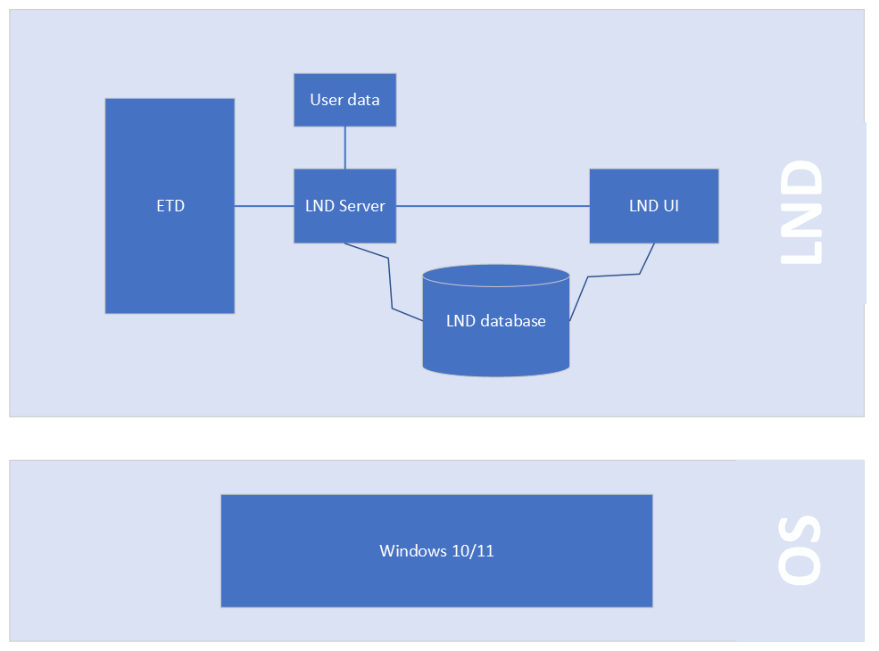
Figure 1: Local Node System Architecture

The ETS Local Node components
- ETD (Eye Tracking Device)
- LND Server, mainly responsible to get the data from the eye tracking device
- LND local DB
- LND User Interface

Co-hosting and connectivity notes
- LND Server with ETD should be hosted on the same computer, along with LND config file and LND database.

Background and foreground components
The below two components will not expose a user interface:
- LND Server
- Local DB
The following components will expose its UI in the primary Windows display:
- LND UI

General overview
The Eye Tracking System Suite is a collection of software apps that will be used to setup a fully functionally local node.
The ETS apps are:
- ETSDVM Eye Tracking System Device Manager Service (LND Server)
- ETSUI Eye Tracking System User Interface (LND UI)7

Local Node alternative configuration schemes
The software “components” within the LND System Architecture, allow a number of alternative configuration schemes for an LND Node, but for the project we are going to work with only one possible configuration scheme.
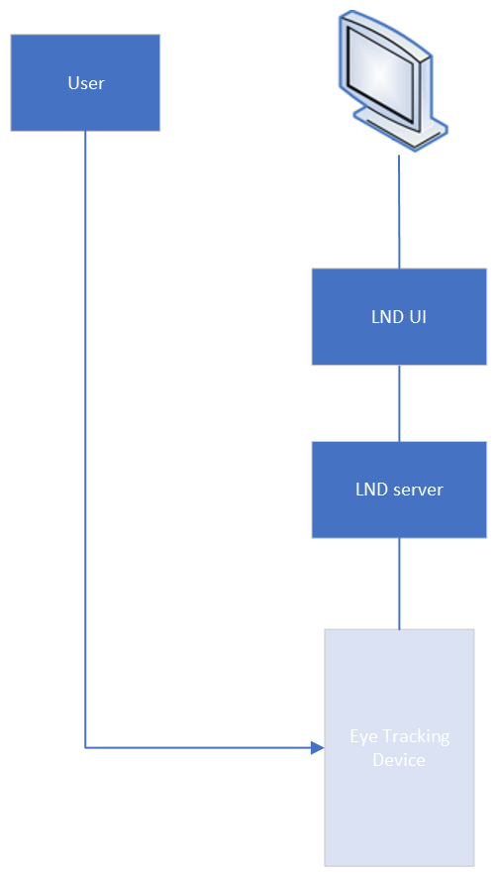
Figure 2: Configuration Scheme
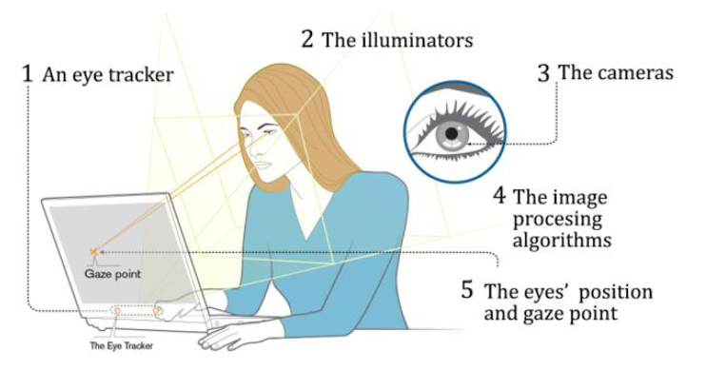
Figure 3: Real-time example

ETSDVM – Device Manger Service
The Eye Tracking System Device Manager Service (ETSDVM) is the app responsible to manage the Eye Tracking device. For this purpose it is directly connected to the devices at the physical layer.

Important note on Eye Tracking device availability for ETSDVM
ETSDVM app will not start in case that ETD is detected to be disconnected; i.e. powered-off or unplugged. If Eye Tracking Device starts properly (as connected), but it is disconnected any time later on, then ETSDVM will stop working, since this kind of problem is “unrecoverable”. It will be required to fix the Eye Tracking device connection and restart the ETS Suite.
When ETD is detected as disconnected, then ETSUI:
- Will not service any request for data, answering “Service Unvavailable” to user.
- Will not allow user enter to features that include communication with the device.

Features
The ETSDVM app features list:
- Tobii Pro SDK
- No access to screen display
- Events logging

Health monitoring of ETD
DVM is periodically monitoring the Eye Tracking Device health. This is implemented via an auto-reset timer in module DriverETD. The timer event will be named timerMonitoringEvent(), which is running asynchronously in a background thread.
Before interrogating the ETD, asking for health info data, we ensure full ownership of the device driver (via the custom synchronization variable). ETD custom method GetHealthInfoAsync() used for health data collection from device firmware. The health monitoring is executed periodically by ETSDVM, the period will be configurable. There will be an appsettings.json file that will configure this attribute.

ETSUI – User Interface
The ETSUI is a component of ETS node suite. It can be considered as the coordinator of the ETS workflows.
Furthermore, it is:
- The only process which has access to primary screen
- Is loaded upon PC startup as a regular windows user application
- It is a client which is sending requests to:
  - ETSDVM for eye tracking data collection

Features
This is a list profiling the ETSUI app features:
- Is a windows Presentation Framework app
- Logging
- Client, implementing:
  - Streaming responses
  - Deadline (timeout)
  - Logging, include the request/responses
  - Got to have a request retry policy optionally
The ETSUI app functionality is intended to:
- Upon receiving a connection with the eye tracker request from the user, popping the selected pdf file.
- Importing pdf files to the database.
- Have a user settings menu adjusting to each user.
- Basic user authentication.
- Vocabulary builder feature, where the user can see the words that where translated by ETSUI.
- Creating dynamic AOI’s upon opening the saved pdf file.

The Data Model
In this chapter are documented:
- The Database schemas
- The Table Design
R01.00 | Table Name | Content description
T01 | Users | Table of user entities
T02 | User Settings | Table of personalized user settings
T03 | Vocabulary | Table of vocabulary builder, synonyms etc.
T04 | Documents | Table of documents that the user inserts

Users:
Column Name | Data Type | Description
userID | Integer | Primary Key, Auto-increment
username | String | Username of the user
password | String | Hashed password

User Settings:
Column Name | Data Type | Description
userID | Integer | Foreign Key, references Users(UserID)
Selected_language | String | Preferred language of the user
theme | String | Selected theme (dark, light, etc.)
zoomLevel | Integer | Zoom level of the text document

Vocabulary:
Column Name | Data Type | Description
wordID | Integer | Primary Key, Auto-increment
userID | Integer | Foreign Key, references Users(UserID)
word | String | Word saved by the user
usageCount | Integer | Number of times a word has been translated(optional)
synonyms | String | Synonyms of the word in the selected language(optional)

Documents:
Column Name | Data Type | Description
ocID | Integer | Primary Key, Auto-increment
userID | Integer | Foreign Key, references Users(UserID)
docName | String | Name of the document
docFile | Blob | The document file
uploadDate | DateTime | Date and time when the document was uploaded
lastReadPage | Integer | Last read page number (optional)

Project Development
Herein, we will refer to the key aspects of the Project intended to “Develop” this “product”, such as:
- Pre-requisites
Pre-project preparatory requirements
- Testing Lab
The HCI Lab used for Alpha and Beta testing of the project infrastructure which will be developed and delivered in phases. To evaluate efficiency, accuracy and proof of concept of the system an experiment will be conducted also in the HCI Lab.
- Project Plan
The project implementation phases along with an estimated time duration.
- Project Taks
Detailed breakdown of each phase to its primary tasks, until completion of phase deliverables.

Prerequisites
Below are listed the project prerequisites:
- Tobii Pro API SDK Manual
- GitHub Repository
- Desktop eye tracker (Tobii Spectrum)
- Related papers for proof of concept

Testing Lab
- ALPHA testing of the delivered “Product” (delivered in phases)
- Lab Setup: Setting up the necessary hardware and software, including the desktop eye tracker and the connection to the Tobii Pro API.
- Preliminary Tests: Running initial tests to ensure the eye-tracking data is being captured and processed accurately.
- System Integration Testing Confirming that all components of your system (eye tracking data collection, processing, and the assistance mechanism) work together as expected.
- Prototype Testing: Developing and testing a basic prototype of the assistance system to check whether it's correctly utilizing eye-tracking data.
- Usability Testing: Conducting initial usability tests with a small group of users for feedback on system usability.
- Effectiveness Testing: Evaluating whether the system assists users in reading non-native language text. Using pre- and post-tests to gauge improvement.
- Performance Testing: Stress testing the system for reliability under extended operation periods and challenging conditions.
- BETA testing of the delivered “Product” (delivered in phases)
- Pilot Study: Implementing the refined system with a larger group of users for further testing and performance measurement.
- Data Analysis: Analyzing the data collected during the pilot study for insights and areas of improvement.
- Iterative Refinement and Testing: Based on the feedback and data analysis, refining the system and repeating the testing phases as needed until the system meets predefined standards and user satisfaction.
- Final Review and System Validation: Conducting a final review for system validation after satisfactory performance in the Beta testing phase.
Below is the Test Lab with its components:
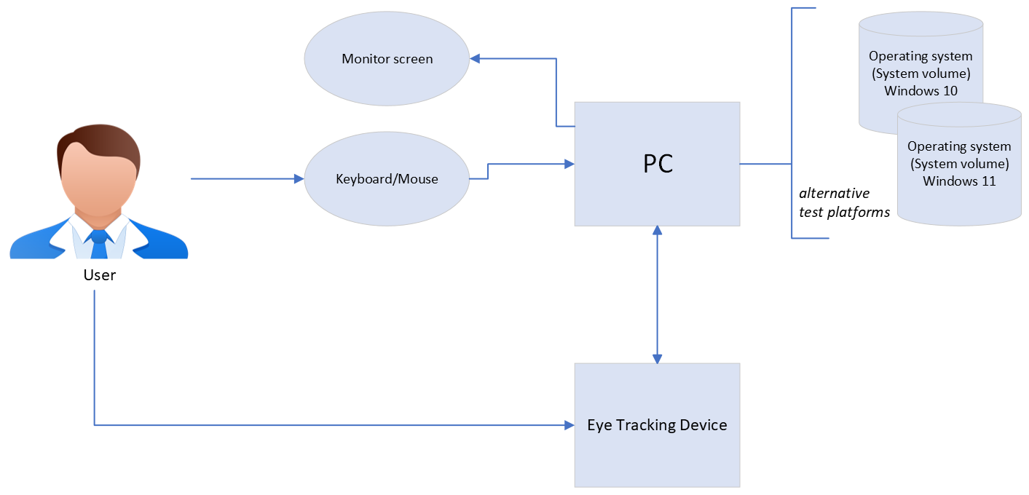
Figure 4: Test Lab
The detailed components for the software to operate are shown in Figure 4. (το σωστό Figure 4)

Project Plan
The ETS “product” development project will be executed in phases. They are presented one by one in the sections below.
Typically, each phase is consisting of the following steps:
- Preparatory actions including architectural design.
- Software development, which is the core activity.
- ALPHA Testing in Dev Lab 4. Documentation of the software release.
- BETA Testing in Test Lab.
- Experiment for proof of concept.
The development of the project will be executed in phases. They are presented one by one in the sections below.
Typically, each phase is consisting of the following steps:
- Preparatory Actions Including Architectural Design: In this step, we will prepare the groundwork for the project. This includes defining the project's requirements, outlining the system's architecture, and planning how each component of the system will interact with each other. This stage also includes creating a project timeline and defining the resources needed.
- Software Development: This is the phase the actual coding happens. Based on the architectural design, the software will be developed in sections based on the decided modules. It is vital to ensure code quality, follow best practices, and maintain good version control using Git.
- ALPHA Testing in Dev Lab: After a portion of the system or the entire system is developed, Alpha testing will be conducted. This is typically conducted within the development environment with a small group of volunteers in order to catch and fix bugs before it reaches the end users. This phase helps to verify the functionality, usability, and consistency of the software.
- Documentation of the Software Release: It's important to document each software release thoroughly. This includes detailed descriptions of new features, bug fixes, and any known issues. Good documentation helps maintain transparency with users and also assists in future development and debugging efforts.
- BETA Testing in Test Lab: In the Beta testing phase, the software is tested in the 'real world' by a selected group of end-users under various environments. This phase helps to find bugs that might not have been caught during Alpha testing. It also helps in understanding how users interact with the software, their experience, and areas that can be improved.
- Experiment: In this phase we will conduct an experiment in order to assess the effectiveness of the developed software.

Project Phases

Detailed breakdown of each phase to its primary tasks:
Task | Sub-Task | Start Date | End Date
Phase 1: Project Description
1.1 Literature Review | 1.1.2 Literature Review | 3-May-23 | 7-May-23
 | 1.1.3 Analyze Found Literature | 7-May-23 | 13-May-23
1.2 Feasibility Study | 1.2.1 Identify Technical Requirements | 7-May-23 | 17-May-23
 | 1.2.2 Assess Resource Availability | 17-May-23 | 23-Jun-23
1.3 Project Description Document | 1.3.1 Outline the Document | 24-Jun-23 | 26-Jun-23
 | 1.3.2 Write the Document | 26-Jun-23 | 4-Jul-23

Task | Sub-Task |  | Start Date | End Date
Phase 2: Project Development
2.1 Read the Tobii Pro API manual | 2.1.2 Initial Reading |  | 4-Jul-23 | 6-Jul-23
 | 2.1.3 Detailed understanding and Notes |  | 6-Jul-23 | 15-Jul-23
2.2 Development of Software Infrastructure | 2.2.1 Development of basic Infrastructure |  | 10-Jul-23 | 15-Jul-23
 | 2.2.2 Implementation of Additional Features |  | 15-Jul-23 | 30-Jul-23
2.3 Development of Database | 2.3.1 Database Design |  | 5-Aug-23 | 7-Aug-23
 | 2.3.2 Database Implementation |  | 8-Jul-23 | 13-Aug-23
2.4 Implementation of Tobii Pro API | 2.4.1 Basic Implementation |  | 17-Jul-23 | 1-Sept-23
 | 2.4.2 Testing and Refinement |  | 2-Sept-23 | 5-Sept-23
2.5 Alpha Test of Software Infrastructure | 2.5.1 Internal Testing |  | 6-Sept-23 | 8-Sept-23
 | 2.5.2 Refinement Based on Results |  | 9-Sept-23 | 11-Sept-23
2.6 Beta Test of Tobii Pro Software | 2.6.1 External User Testing |  | 12-Sept-23 | 14-Sept-23
 | 2.6.2 Refinement Based on Results |  | 14-Aug-23 | 17-Sep-23
2.7 Project Deployment |  |  | 17-Sep-23 | 17-Sep-23
Phase 3: Experiment
3.1 Experiment Design |  | 3.1.2 Establish Goals and Hypotheses | 18-Sep-23 | 20-Sep-23
 |  | 3.1.3 Develop Test Scenarios | 20-Sep-23 | 24-Sep-23
3.2 Experiment Protocol Document |  | 3.2.1 Write Protocol | 25-Sep-23 | 27-Sep-23
3.3 Pilot Study (on site) |  | 3.3.1 Conduct Study | 27-Sep-23 | 28-Sep-23
 |  | 3.3.2 Analyze Pilot Results | 28-Sep-23 | 30-Sep-23
3.4 Experiment Procedure (on site) |  | 3.4.1 Conduct Experiment | 1-Oct-23 | 20-Oct-23
 |  | 3.4.2 Ongoing Data Collection | 5-Sep-23 | 23-Oct-23
3.5 Analysis of Experiment Results |  | 3.5.1 Initial Data Analysis | 24-Oct-23 | 25-Oct-23
 |  | 3.5.2 Detailed Analysis and Interpretation | 25-Oct-23 | 30-Oct-23
3.6 Report of Experiment Results |  | 3.6.1 Draft Report | 30-Oct-23 | 31-Oct-23
 |  | 3.6.2 Finalize Report | 31-Oct-23 | 29-Aug-23

Task | Sub-Task | Start Date | End Date
Phase 4: Thesis
4.1 Writing Thesis | 4.1.1 Draft Chapters | 1-Nov-23 | 15-Nov-23
 | 4.1.2 Review and Edit Chapters | 15-Nov-23 | 22-Nov-23
 | 4.1.3 Incorporate Feedback | 22-Nov-23 | 25-Nov-23
4.2 Finalizing Thesis | 4.2.1 Review and Edit | 25-Nov-23 | 26-Nov-23
4.3 Thesis Presentation | 4.3.1 Prepare Slides | 26-Nov-23 | 28-Nov-23
 | 4.3.2 Rehearse Presentation | 28-Nov-23 | 29-Nov-23
 | 4.3.3 Presentation | 29-Nov-23 | 30-Nov-23

System Architecture Overview
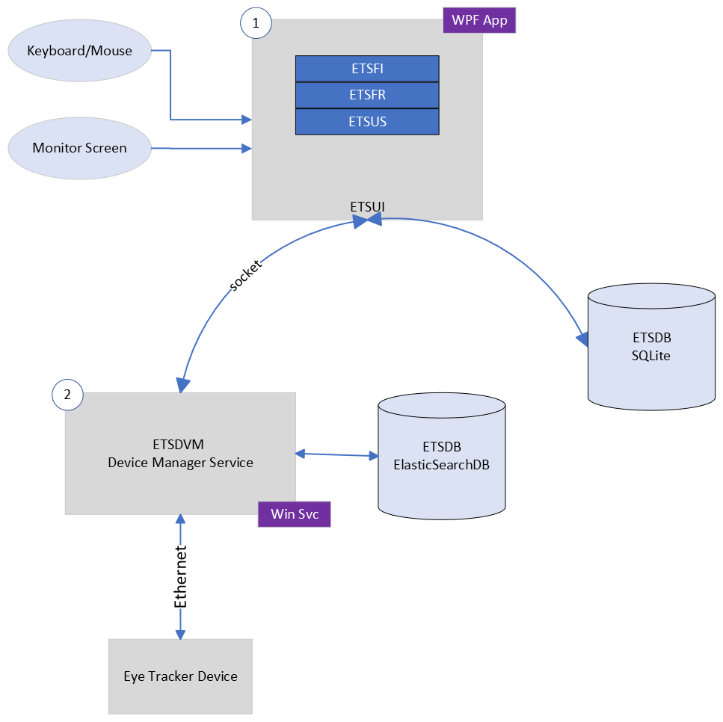
Figure 5: ETS System Architecture Overview

Fundamental Operation Workflows

We will cover the following operations:
- Provide input Insert PDF
- Text Formatting Adjust text settings on the document
- System Calibration adjust hardware to user
- Text Reading Using the eye tracker hardware
- User settings e.g., Language Change
- Vocabulary Save the unknown words to a vocab
- Progress tracking Track and display user's reading progress with visible progress bar, page/section count, and time spent. (optional)

The system’s workflows are presented below in sequence diagrams:

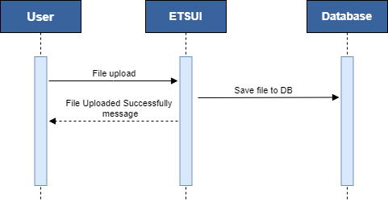

Figure 6: File upload
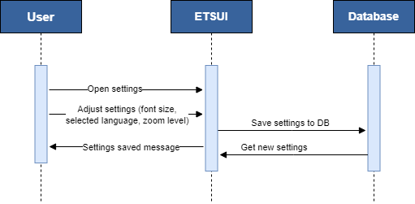
Figure 7: Adjust settings/preferences

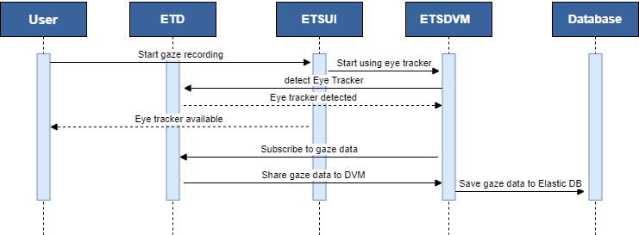
Figure 8: Sharing gaze data between entities

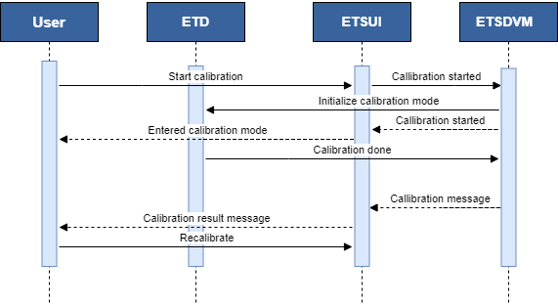
Figure 9: Calibration process

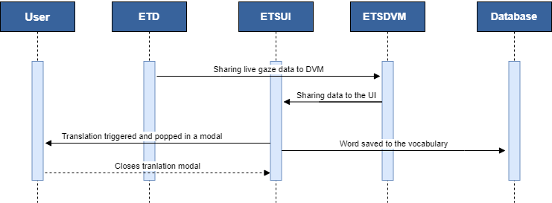
Figure 10: Translation triggering mechanism

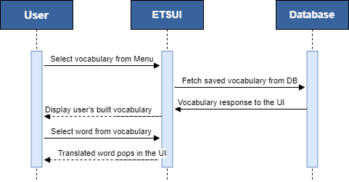
Figure 11: Vocabulary lookup

Tobii Pro SDK
The Tobii Pro SDK provides raw data streams (gaze data, eye images, etc.) from the eye tracker. This allows to collect data and use it in ETS or save it to the database.
However, it does not provide a direct way to calculate metrics like fixation duration, saccade length, etc. These higher-level metrics have to be custom. The metrics we need to calculate are:
- Fixation Duration: To understand how users perceive words and AOIs in general, fixation duration is a good metric to consider. Higher fixation durations can signal a higher level of interest whereas shorter fixation durations might mean other objects or areas of interest are more attention-grabbing or frustrating. It’s hard to determine frustration based solely on this metric though, and requires corroborative metrics and data. This metric is calculated by the total time fixated on a word or area of interest.
- Fixation Count: A high number of fixations, meaning the suer repeatedly revisits the same word or AOI could mean a high level of interest. However, it could also indicate difficulty with comprehension. While this metric cannot tell you how users feel when looking at something, it provides data as to what should be examined further.
- Fixation rate: A low rate of fixation indicates the stop of moving and fixate on a particular point, is an important measure in eye-tracking studies and can indeed indicate cognitive load.
- Saccades: Rapid movements of the eye between fixation points can indicate a pattern to seem to jump back and forth between specific words, these might be potential targets for translation.
- Pupil dilation: Changes in pupil size can reflect cognitive load. An increase in pupil size might indicate difficulty in comprehension.
- Blink rate: Rate and latency of blinking activities can be another eye tracking metric providing information about a user’s cognitive load. Blinking can be a voluntary eye movement although, most of the time, it is an involuntary eye movement although, most of the time, it is an involuntary movement. The rate and latency of blinks can help to provide a deeper understanding about the state of attention of the participant.
After the analysis of each metric, we have to combine them in order to decide when the translation of the word will occur.

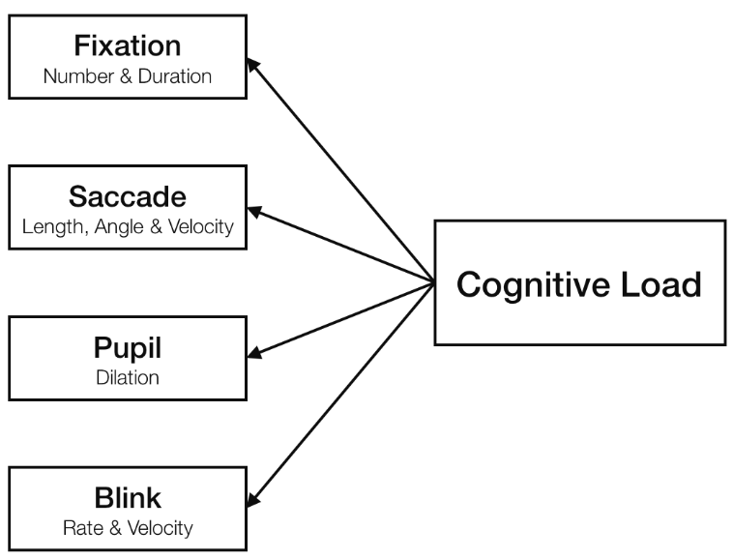
Figure 12: Model of eye-based indicators of cognitive load

Epilogue
Versions A01 and A02 of Project Description Document were intended for Project Assessment by contemplated project owner. With each version of this Project Description Document, we've refined our plan, progressing from initial concept to a comprehensive blueprint. Upon final approval, this document will serve as the guiding Project Specification. The ideas within these pages will soon evolve into actions, steering us into the crucial phase of implementation. As we conclude this part of our journey, we anticipate the exciting path ahead, ready to bring our vision to life.

Glossary
API | Application programming Interface | set of protocols for building software applications
ETS | Eye Tracking System | Eye Tracking System
ETD | Eye Tracking Device | Device that tracks the eye movements upon a screen
LND | Local Node | All h/w and s/w comprising a payment server with satellite components
DB | Database | Database
ETSFR | ETS File Reader | ETS that read the saved file
ETSFI | ETS File Input | ETS File Input System
ETSUS | ETS User Settings | ETS customization upon user preferences
ETSDVM | ETS Device Manager Service | App that takes raw data from ETD
AOI | Area of Interest | Defined region in the stimulus where eye-tracking data is specifically calculated and analyzed

Appendix

QUESTIONS:
Do we need a data stream channel?
Do we need to save the eye tracking data in a database? Probably yes
Απαντώ και στα δύο… Αφού έχεις συνεχή ροή δεδομένων από τον eye-tracker που θέλεις να επεξεργάζεσαι και να παίρνεις απόφαση σε πραγματικό χρόνο τότε προφανώς και θέλεις.
Αντίθετα στην τελική εφαρμογή δεν χρειάζεται να έχεις τα δεδομένα στη DB. Η εφαρμογή θα παίρνει απόφαση σε πραγματικό χρόνο με βάση τη ροή δεδομένων θα δίνει τη μετάφραση και μετά δεν τα χρειάζεσαι… όμως…
Για τη δουλειά που θα κάνεις για να αποφασίσεις ποια λέξη χρειάζεται να δώσεις μετάφραση θα πρέπει να αναλύσεις αυτά τα δεδομένα. Άρα τα θέλεις κάπου αποθηκευμένα. Μάλιστα αν έχεις αποθηκεύσει και τα δεδομένα από κάθε χρήστη που έκανε το πείραμα, τότε μπορείς να βγάλεις και άλλα ερευνητικά συμπεράσματα μετά (ίσως και κάτι που δεν το είχαμε σκεφτεί σήμερα), άρα ΝΑΙ σίγουρα να τα φυλάξεις!

What are the eye tracking measures that are applicable to analyze cognitive load in visual computing?
Δεν έχει σχέση με τη διπλωματική… όλες οι μετρικές που αναφέρεις παραπάνω έχουν σχέση, αλλά εσύ δεν θέλεις να αναλύσεις αυτό. Εσύ θέλεις να εντοπίσεις λέξεις που ο χρήστης θα ήθελε να δει σε μετάφραση. Εκτιμώ ότι αυτό θα το βρεις με πολύ λιγότερες μετρικές (και θα το δείξουν τα πειράματα, αν και ήδη υπάρχουν μελέτες -και πολλές- για το πώς ένας χρήστης διαβάζει κείμενο). Το cognitive load εξαρτάται και από άλλους παράγοντες, και δεν έχει νόημα σε αυτή τη φάση. Από τα δεδομένα που θα έχουμε ίσως βγάλουμε και τέτοια συμπεράσματα, αλλά είναι μάλλον future goal!

Which aspects of Human-Computer Interaction influence cognitive load?
Πάρα πολλοί, αλλά τι σχέση έχει με τη διπλωματική σου; Ο ποιο σημαντικός είναι η πολυπλοκότητα της διεργασίας, αλλά προφανώς και η σχεδίαση του UI και άλλα πολλά (και μερικά εξωγενή όπως το περιβάλλον εργασίας, οι εξωτερικές παρεμβολές, τα προσωπικά χαρακτηριστικά του χρήστη, όπως ο τρόπος που αντιλαμβάνεται και διαχωρίζει πληροφορίες, κτλ.)

How can we analyze cognitive load in visual computing using eye tracking?
Με πολλούς τρόπους, όχι μόνο eye-tracking data, π.χ. physiological data (με ποιο συνηθισμένα BVP, GSR, EEG), video emotion analysis, observation, κτλ. Αλλά επίσης δεν αφορά τη διπλωματική αυτή.

